# Vergennes Virtual Junior Fishing Derby

## Mission Statement:

The Vergennes Junior Fishing Derby seeks to introduce young people to the benefits and enjoyment of fishing and to encourage them to share the sport with others.

## Rules and Regulations

1. All VT Fish and Wildlife rules and regulations pertaining to Lake Champlain apply to all participants, supervising adults and spectators. It is the responsibility of each to become familiar with the local, state and federal laws that may apply to them. This includes practicing proper boating etiquette at all times. A copy of the current State Digest is available upon request via email.
2. **The Vergennes Junior Fishing Derby is a DRUG, ALCOHOL and TABACCO free event.** The use of alcohol or illegal drugs by the participants, their parents, and guardians is prohibited at all times.
3. All persons who have reached the age of 3 by the first day and have not yet reached the age of 16 by the last day shall be eligible for participation in the Derby.
4. Registrations will take place in advance prior to the first day of the derby. All participants must register and receive an entry number and ID prior to fishing and entering any fish
5. The derby boundaries will be clearly marked in the Vergennes Falls Basin.
6. Fish will be entered by weighing your fish at the nearest weigh station located on either side of the basin. **Fish caught outside of the derby boundaries are not eligible .**
7. All participants must have immediate control of their fishing line(s) at all times, as described in the VT Fish and Wildlife Digest. If a participant cannot for ANY reason be in immediate control of their line(s), they must reel them in until such a time when they can resume immediate control. Participants are to yield to any other participant that has a FISH ON and shall make every effort to allow the participant to play and land the fish without interfering. All participants, supervising adults and spectators are encouraged to help teach proper fishing etiquette and behavior. **All participants under 12 years of age must be accompanied by an adult.** All other participants are encouraged to have adult supervision.
8. Any participant found to be in violation of any rules or regulations of the Vergennes Junior Fishing Derby, the Vermont Fish and Wildlife Department, the State of Vermont or the City of Vergennes shall be disqualified. **Absolutely NO disruptive, destructive or disrespectful behavior will be tolerated. This includes but is not limited to Damage to the Environment, Wildlife or People, Fighting, Pushing, Rock Throwing, Bouncing on and/or Rocking the various Docks, Swimming in the Contest Area, and Using Foul Language.** We must also all be mindful of boaters and other visitors who come to enjoy our natural resources but are not part of the Derby, they should feel welcome at all times.
9. **Absolutely NO baby strollers on any floating dock at any time.** All participants should wear a US Coast Guard Approved Life Jacket when on any floating dock.
10. **Absolutely NO OVERNIGHT or DAY CAMPING will be allowed during the Derby.** Both sides of the Basin close at sunset. Derby participants are expected to leave the premises after Derby activities.
11. Children are encouraged to wear footwear at all times.
12. The City of Vergennes is not responsible for items lost or stolen.

## BOATING

Boaters must follow all U.S Coast Guard and State regulations. Otter Creek Speed limit is NO WAKE or a Maximum of 5 MPH whichever comes first.

Divisions

1. Ages 3-7
2. Ages 8-15

Eligible Species

*Rainbow, Brown, Lake Trout / Atlantic Salmon (Category 1)*

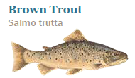 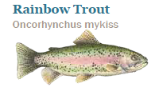 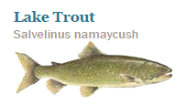 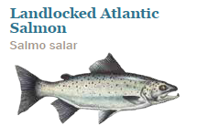

*Smallmouth/ Largemouth Bass (Category 2)*

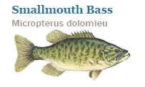 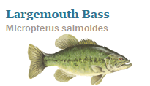

*Walleye/ Northern Pike (Category 3)*

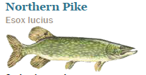 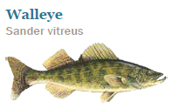

**Each Participant may only submit 2 entries per category.**

*Carp/Sucker/ Catfish (Category 4)*

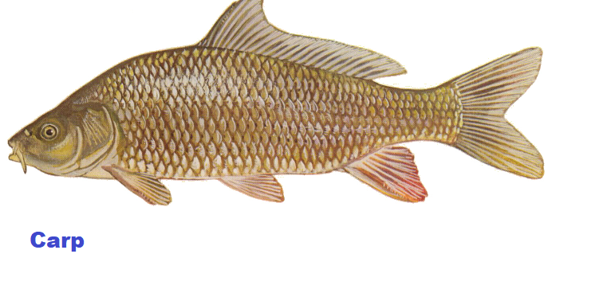 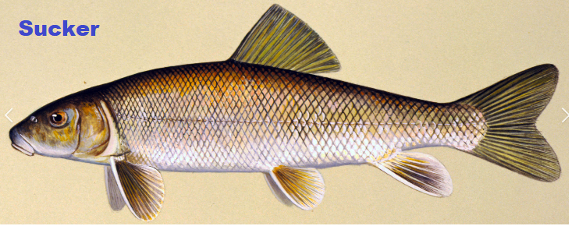 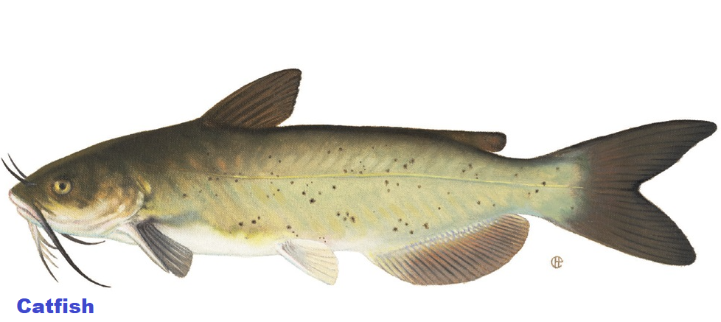

*Sheephead/ Bowfin (Category 5)*

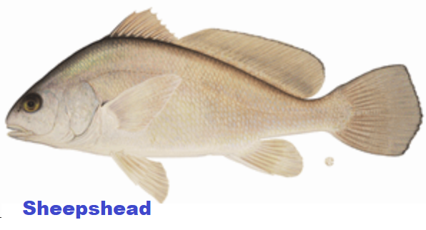 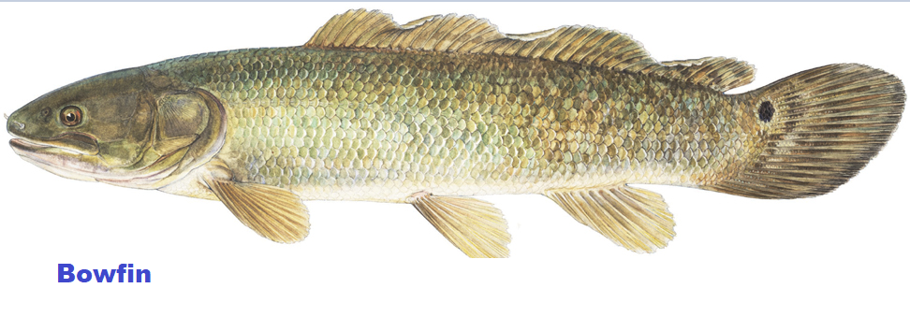

Yellow Perch (Division 1 only) 8 Inch minimum (not eligible for grand prize)

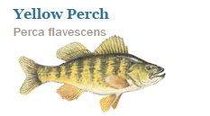

Size Restrictions

|  |  |
| --- | --- |
| Species | Minimum Length |
| Brown, Rainbow, Lake Trout/ Atlantic Salmon | 15 “ |
| Largemouth/ Smallmouth Bass | 12” |
| Walleye | 18” |
| Northern Pike | 20” |
| Carp, Sheepshead, Catfish, Bowfin, Sucker | 12” |
| Yellow Perch (Ages 3-7 only) | 8” |